Practical :- 1.1
Aim :- Write a Python program to check whether a given year is a leap year or not.
Program :-
year = int(input("Enter the year you want to check whether it's leap or not :: "))
year = year % 2

if year == 0:
print("It is leap year. ")
else:
print("It's not the leap year. ")
Output :-
Practical :- 1.2
Aim :- Write a Python program to generate and print the Fibonacci series up to a specified number of terms.
Program :-
fibo = int(input("Enter the integer till where you want to print the fibonacci series :: "))
first_num = 0
second_num = 1

print(first_num)
print(second_num)

for i in range(1,fibo):
sum = first_num + second_num
print(sum)

first_num = second_num
second_num = sum
Output :-
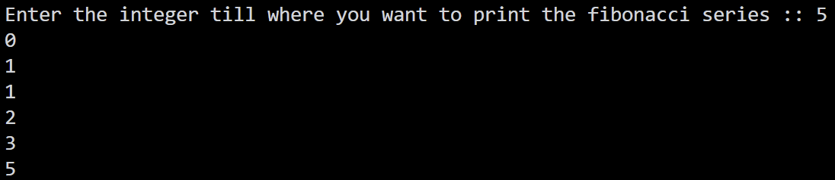
Practical :- 1.3
Aim :- Write a Python program to print a right-angled triangle and inverted star pyramid pattern.
Program :-
right_ang_tri_pyramid = int(input("Enter the number of level you want to print :: "))

for i in range(1, right_ang_tri_pyramid + 1):
for j in range(1, i + 1):
print("*",end = " ")
print()

print()

for i in range(right_ang_tri_pyramid, 0, -1):
for j in range(1, i):
print(" ", end = "")
for k in range(i, right_ang_tri_pyramid + 1):
print("*", end = " ")
print()
Output :
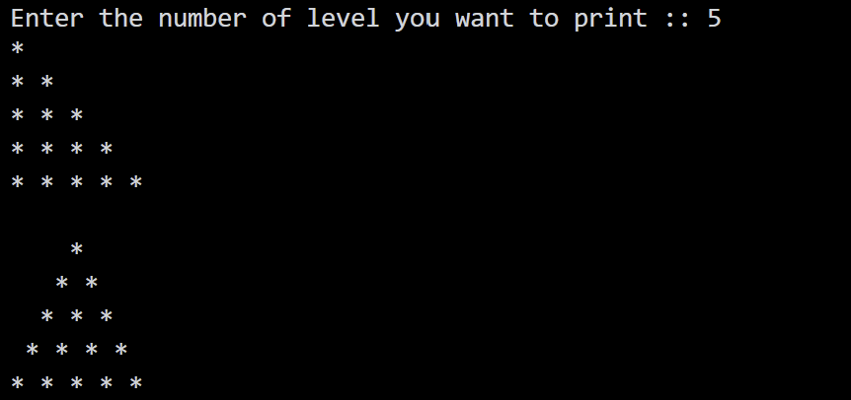
Practical :- 1.4
Aim :- Write a Python program to create a simple calculator supporting basic arithmetic operations (+, -, *, /).
Program :-
first_num = int(input("Enter the first number :: "))
operator = str(input("Entre the operator from (*, /, +, -) :: "))
second_num = int(input("Enter the second number :: "))

if operator == "*" or operator == "/" or operator == "+" or operator == "-":
if operator == "*":
print(first_num * second_num)
elif operator == "/":
print(first_num / second_num)
elif operator == "+":
print(first_num + second_num)
elif operator == "-":
print(first_num - second_num)
else:
print("Some thing went wrong.")
else:
print("Select proper operator.")
Output :-
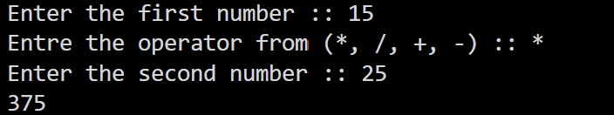

Practical :- 2.1
Aim :- Write a Python program to check whether a given string is a palindrome.
Program :-
string = str(input("Enter the string you want to check whether it is palindeome or not :: "))
reverse_string = string[::-1]

if reverse_string == string:
print("String is palindrome.")
else:
print("String is not palindrome.")
Output :-
Practical :- 2.2
Aim :- Write a Python program to find the maximum, minimum, and distinct unique elements (using set) from a user-input list.
Program :-
list_num = int(input("Enter the number of item you want to store in the list :: "))
input_list = []

for i in range(0, list_num):
item = input()
input_list.append(item)

print("Your list is :: ", input_list)

max = input_list[0]
min = input_list[-1]

for i in range(0, list_num):
if input_list[i] > max:
max = input_list[i]
if min > input_list[i]:
min = input_list[i]

print(f"Maximun number form the list is :: {max}\nMinimum number from the list is :: {min}")

print(set(input_list))
Output :-
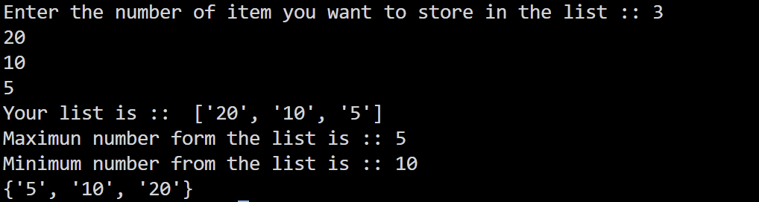
Practical :- 2.3

Aim :- Write a Python program to count the frequency of each character in a given string using a dictionary.
Program :-
text = input("Enter a string: ")

frequency = {}

for char in text:
if char in frequency:
frequency[char] += 1
else:
frequency[char] = 1

print("Character frequencies:")
for char, count in frequency.items():
print(f"'{char}' : {count}")
Output :-
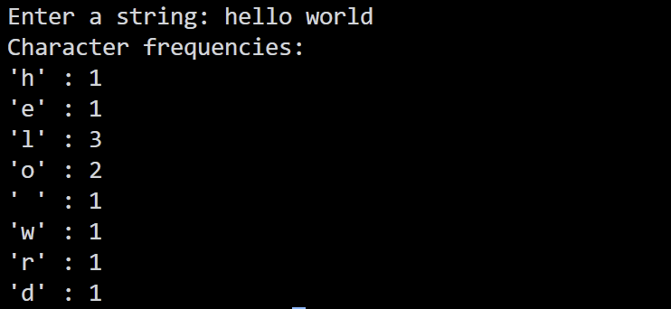
Practical :- 2.4
Aim :- Write a Python program to sort and display student marks in descending order.
Program :-
students = {
"Nick": 100,
"Alice": 95,
"Bob": 87,
"Charlie": 42,
"David": 68,
"Eva": 91,
"Frank": 35,
"Grace": 78,
"Henry": 49,
"Isabella": 98,
"Jack": 56,
"Karen": 72,
"Liam": 83,
"Mia": 64,
"Nathan": 27,
"Olivia": 94,
"Peter": 51,
"Quinn": 39,
"Ryan": 76,
"Sophia": 89,
"Thomas": 44,
"Uma": 67,
"Victor": 31,

"William": 93,
"Xavier": 18,
"Yvonne": 85,
"Zachary": 59,
"Aarav": 73,
"Vivaan": 47,
"Aditya": 81,
"Diya": 96,
"Ananya": 88,
"Ishaan": 53,
"Krishna": 62,
"Meera": 79,
"Rohan": 25,
"Priya": 70,
"Sneha": 92,
"Rahul": 38,
"Kiran": 57,
"Neha": 84
}

value = list(students.items())

for i in range(len(value)):
for j in range(i + 1, len(value)):
if value[i][1] < value[j][1]:
# Swap
value[i], value[j] = value[j], value[i]

desc = dict(value)
print(desc.values())
Output :-

Practical :- 3.1
Aim :- Write a program to read a text file, count the number of words, lines, and characters, and write the output to a new file.
Input File (example.txt) :-
Hello World.
The Earth Is Flat.
No The Earth Is Donut.
Program :-
# Write a program to read a text file, count the number of words, lines, and
# characters, and write the output to a new file.

import os

if not os.path.exists("example.txt"):
with open ("example.txt", "w") as f:
f.write("Hello World.\n")
f.write("The Earth Is Flat.\n")
f.write("No The Earth Is Donut.\n")

character_count = 0
word_count = 0
count = 0

with open ("example.txt", "r") as f:
for line in f:
count += 1

for word in line.split():
word_count += 1

character_count += len(line)

print("Total number of line in the file is :: ",count)
print("The total number of word in the file is :: ",word_count)
print("Total number of character in the file is :: ",character_count)
Output :-
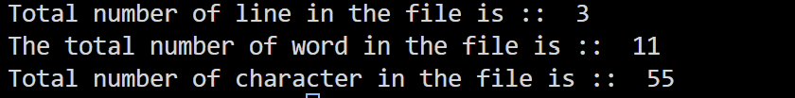
Practical :- 3.2
Aim :- Use the csv module to create a CSV file containing student details (Name, Roll No, CGPA). Read the CSV and display only students with CGPA > 7.5.
Input File (student.csv) :-
Name,Roll NO.,CGPA
Nick,21,9.69
Rock,22,9.01
Nicky,23,8.0
Rockety,24,9.3
Program :-
# Use the csv module to create a CSV file containing student details (Name,
# Roll No, CGPA). Read the CSV and display only students with CGPA > 7.5.

import os
import csv

student_detail = [
["Name", "Roll NO.", "CGPA"],
["Nick", 21, 9.69],
["Rock", 22, 9.01],
["Nicky", 23, 8.0],
["Rockety", 24, 9.3]
]

if not os.path.exists("student.csv"):
with open("student.csv", "w", newline="") as f:
write_csv = csv.writer(f)
write_csv.writerows(student_detail)

with open("student.csv", "r") as f:
reade_csv = csv.reader(f)
for cpi in reade_csv:
if cpi[0] != "Name" and float(cpi[2]) > 7.5:
print(cpi[2])
Output :-
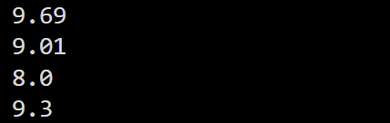
Practical :- 3.3
Aim :- Create a JSON file containing book details (Title, Author, Price). Read and parse the JSON file to display the details.
Input File (book.json) :-
[
{
"Title" : "Minecraft",
"Author" : "Java",
"Price" : 88
},
{
"Title" : "Harry porter",
"Author" : "Nelson Mendela",
"Price" : 67
},
{
"Title" : "GTU",
"Author" : "No One",
"Price" : 0.6767
}
]
Program :-
import json
import os

data = ""

with open("book.json", "r") as f:
data = json.load(f)

for book in data:
print("Title :: ", book["Title"])
print("Author :: ", book["Author"])
print("Price :: ", book["Price"])
print()
Output :-
Title :: Minecraft
Author :: Java
Price :: 88

Title :: Harry porter
Author :: Nelson Mendela
Price :: 67

Title :: GTU
Author :: No One
Price :: 0.6767

Practical :- 3.4
Aim :- Write a program that deliberately divides a number by zero and handles the ZeroDivisionError. Also, handle FileNotFoundError when trying to open a non-existent file.
Program :-
try:
num1 = float(input("Enter numerator: "))
num2 = float(input("Enter denominator: "))
result = num1 / num2
except ZeroDivisionError:
print("Error: Division by zero is not allowed.")

filename = input("Enter filename to open: ")
try:
with open(filename, "r") as file:
content = file.read()
except FileNotFoundError:
print("Error: The requested file was not found.")
Output :-
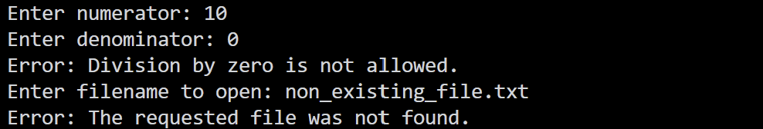

Practical :- 4.1
Aim :- Write a Python program (using the statistics module) to calculate Mean, Median, Mode, Variance, and Standard Deviation for a given list of student marks.
Program :-
import statistics

marks = list(map(float, input("Enter the marks separated by space :: ").split()))

print("Mean :: ", statistics.mean(marks))
print("Median :: ", statistics.median(marks))
print("Mode :: ", statistics.mode(marks))
print("Variance :: ", statistics.variance(marks))
print("Standard deviation :: ", statistics.stdev(marks))
Output :-
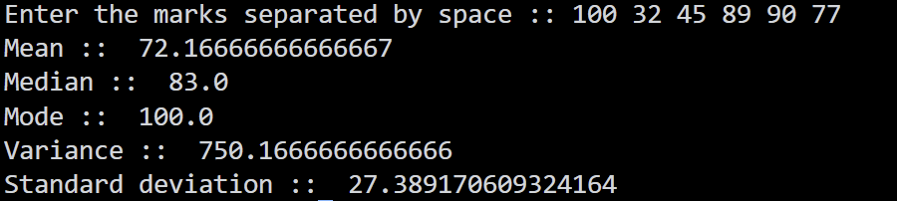
Practical :- 4.2
Aim :- Create two lists representing Math and Science scores. Calculate the Covariance and Correlation Coefficient between them using basic Python formulas or numpy.
Program :-
math_score = list(map(float, input("Enter the Math scores separated by space :: ").split()))
science_score = list(map(float, input("Enter the Science scores separated by space :: ").split()))

if len(math_score) == len(science_score):
math_mean = sum(math_score) / len(math_score)
science_mean = sum(science_score) / len(science_score)

covariance = 0
math_variance = 0
science_variance = 0

for i in range(len(math_score)):
math_difference = math_score[i] - math_mean
science_difference = science_score[i] - science_mean

covariance += math_difference * science_difference
math_variance += math_difference ** 2
science_variance += science_difference ** 2

covariance = covariance / len(math_score)
correlation = covariance / ((math_variance / len(math_score)) ** 0.5 * (science_variance / len(science_score)) ** 0.5)

print("Covariance :: ", covariance)
print("Correlation coefficient :: ", correlation)

else:
print("Both lists must contain the same number of scores.")
Output :-
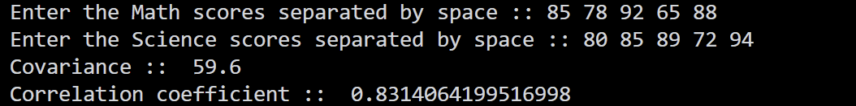
Practical :- 4.3
Aim :- Simulate rolling a six-sided die 1000 times using the random module. Plot the frequency distribution of the outcomes.
Program :-
# Simulate rolling a six-sided die 1000 times using the random module. Plot the # type: ignore
# frequency distribution of the outcomes (using basic text output or a simple
# bar chart).

import random

frequency = [0, 0, 0, 0, 0, 0]

for i in range(1000):
roll = random.randint(1, 6)
frequency[roll - 1] += 1

for i in range(6):
print(i + 1, "::", frequency[i], "*" * (frequency[i] // 10))
Output :-
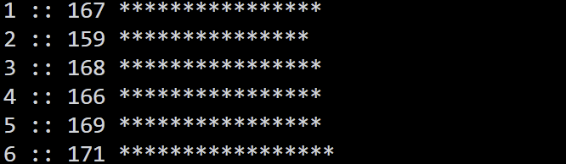
Practical :- 4.4
Aim :- Calculate the probability of drawing an Ace from a standard deck of 52 cards using a Python simulation.
Program :-

import random

deck = ["Ace"] * 4 + ["Other"] * 48
total_draws = 1000
ace_count = 0

for i in range(total_draws):
card = random.choice(deck)
if card == "Ace":
ace_count += 1

probability = ace_count / total_draws

print("Number of Aces drawn :: ", ace_count)
print("Total number of draws :: ", total_draws)

print("Probability of drawing an Ace :: ", probability)

Output :-

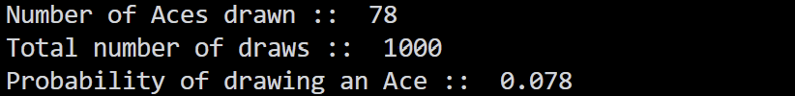

Practical :- 5.1
Aim :- Create a 1D array of 10 elements and a 2D array of shape (3,4). Perform basic arithmetic operations (addition, multiplication) on them.
Program :-
import numpy as np

arr_1d = np.arange(1, 11)
arr_2d = np.arange(1, 13).reshape(3, 4)

print("1D Array:")
print(arr_1d)

print("\n2D Array:")
print(arr_2d)

print("\n1D Array + 5:")
print(arr_1d + 5)

print("\n1D Array * 2:")
print(arr_1d * 2)

print("\n2D Array + 5:")
print(arr_2d + 5)

print("\n2D Array * 2:")
print(arr_2d * 2)
Output :-
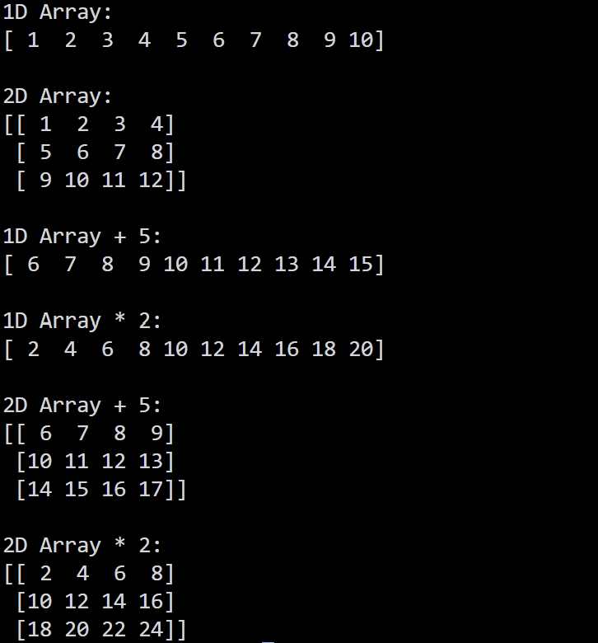
Practical :- 5.2
Aim :- Demonstrate NumPy indexing and slicing: Extract the 2nd row and 3rd column from a 4x4 matrix. Replace all even numbers in the matrix with -1.
Program :-

import numpy as np

matrix = np.arange(1, 17).reshape(4, 4)

print("Original 4x4 Matrix ::\n", matrix)

# Extract 2nd row (index 1) and 3rd column (index 2)
second_row = matrix[1, :]
third_col = matrix[:, 2]

print("\n2nd Row :: ", second_row)
print("3rd Column :: ", third_col)

# Replace all even numbers in the matrix with -1
matrix[matrix % 2 == 0] = -1
print("\nMatrix after replacing all even numbers with -1 ::\n", matrix)
Output :-
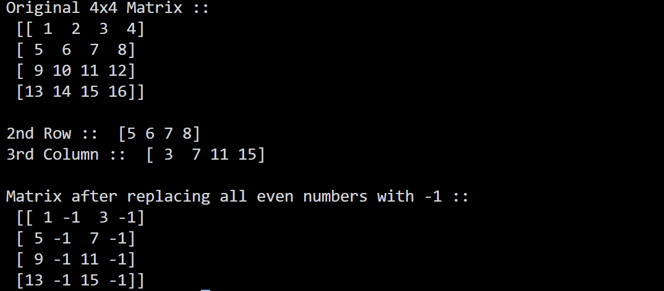
Practical :- 5.3
Aim :- Use NumPy built-in functions: np.zeros, np.ones, np.arange, np.linspace, and np.reshape.
Program :-
import numpy as np

# 1. np.zeros
zeros_arr = np.zeros((3, 3))
print("np.zeros (shape 3x3) ::\n", zeros_arr)

# 2. np.ones
ones_arr = np.ones((2, 4))
print("\nnp.ones (shape 2x4) ::\n", ones_arr)

# 3. np.arange
arange_arr = np.arange(10, 50, 5)
print("\nnp.arange(10, 50, 5) ::\n", arange_arr)

# 4. np.linspace
linspace_arr = np.linspace(0, 10, 5)
print("\nnp.linspace(0, 10, 5) ::\n", linspace_arr)

# 5. np.reshape
original_arr = np.arange(12)
reshaped_arr = np.reshape(original_arr, (3, 4))
print("\nOriginal array for reshape ::\n", original_arr)
print("np.reshape into (3, 4) ::\n", reshaped_arr)

Output :-

Practical :- 5.4
Aim :- Generate two random 3x3 matrices. Perform matrix multiplication, find the transpose, and calculate the determinant of the result.
Program :-
import numpy as np

# Generate two random 3x3 matrices with integers between 1 and 10
matrix_a = np.random.randint(1, 10, size=(3, 3))
matrix_b = np.random.randint(1, 10, size=(3, 3))

print("Matrix A ::\n", matrix_a)
print("\nMatrix B ::\n", matrix_b)

# Matrix multiplication
result_mult = np.matmul(matrix_a, matrix_b)
print("\nMatrix Multiplication Result (A x B) ::\n", result_mult)

# Transpose of the result
result_transpose = result_mult.T
print("\nTranspose of Result ::\n", result_transpose)

# Determinant of the result
result_det = np.linalg.det(result_mult)
print("\nDeterminant of Result :: ", round(result_det, 4))
Output :-
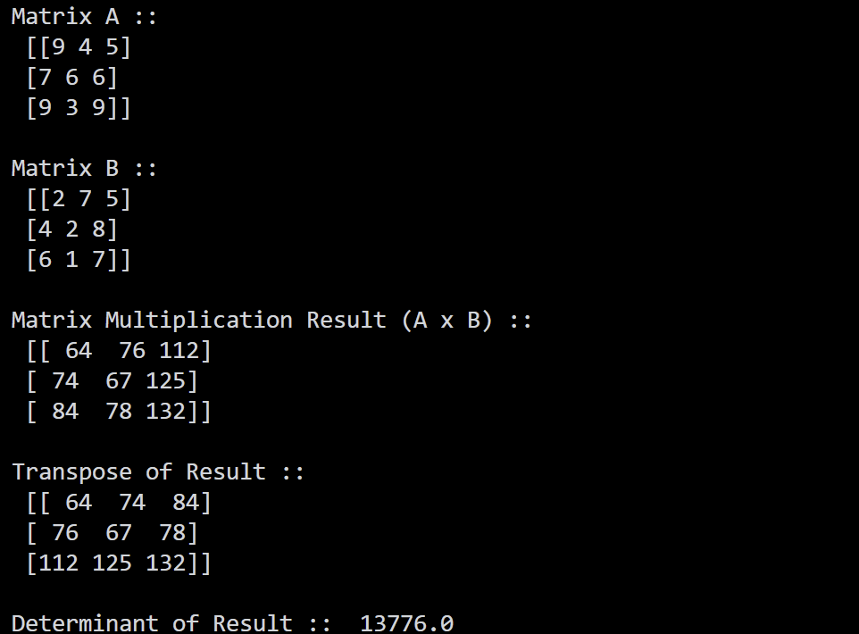
Practical :- 6.1
Aim :- Create a Pandas Series from a list and a dictionary. Perform slicing and basic arithmetic on the Series.
Program :-
import pandas as pd

# Series from a list
s1 = pd.Series([10, 20, 30, 40, 50])
print("Series from List:\n", s1)

# Series from a dictionary
s2 = pd.Series({"Nick": 85, "Rock": 92, "Nicky": 78})
print("\nSeries from Dictionary:\n", s2)

# Slicing
print("\nSlicing:")
print(s1[1:4])

# Basic arithmetic
print("\nAddition:")
print(s1 + 5)

print("\nMultiplication:")
print(s1 * 2)
Output :-
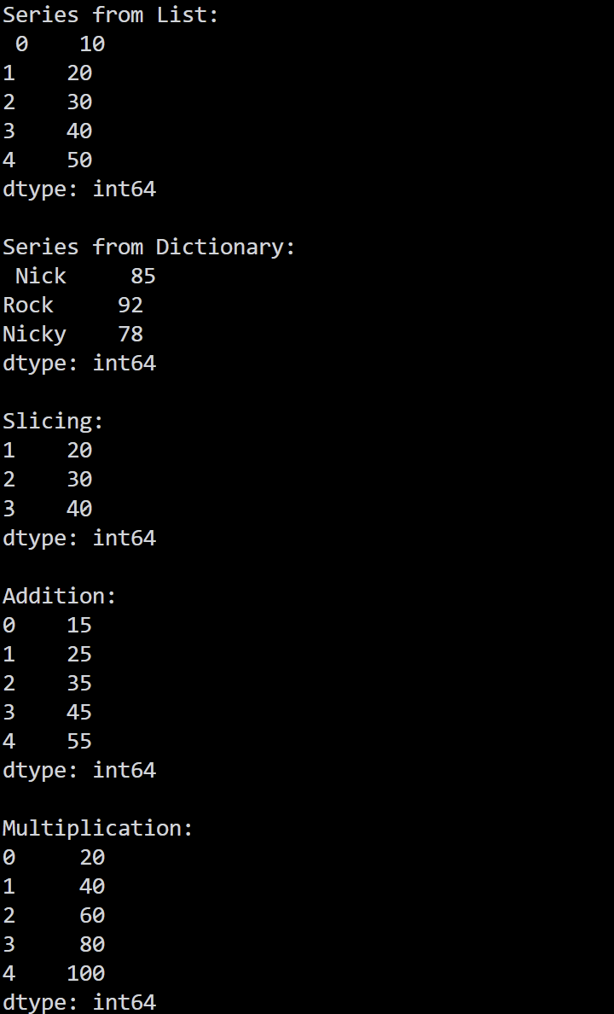
Practical :- 6.2
Aim :- Create a DataFrame from a dictionary containing Employee details (ID, Name, Dept, Salary).

Program :-
import pandas as pd

employee_data = {
"ID": [101, 102, 103, 104, 105],
"Name": ["Nick", "Rock", "Nicky", "Rockety", "Alice"],
"Dept": ["IT", "HR", "Finance", "IT", "Marketing"],
"Salary": [75000, 52000, 68000, 92000, 58000]
}

df_employee = pd.DataFrame(employee_data)

print("Employee DataFrame ::\n", df_employee)
print("\nDataFrame Info ::")
df_employee.info()
print("\nDataFrame Shape :: ", df_employee.shape)
print("\nDataFrame Columns :: ", df_employee.columns.tolist())
Output :-
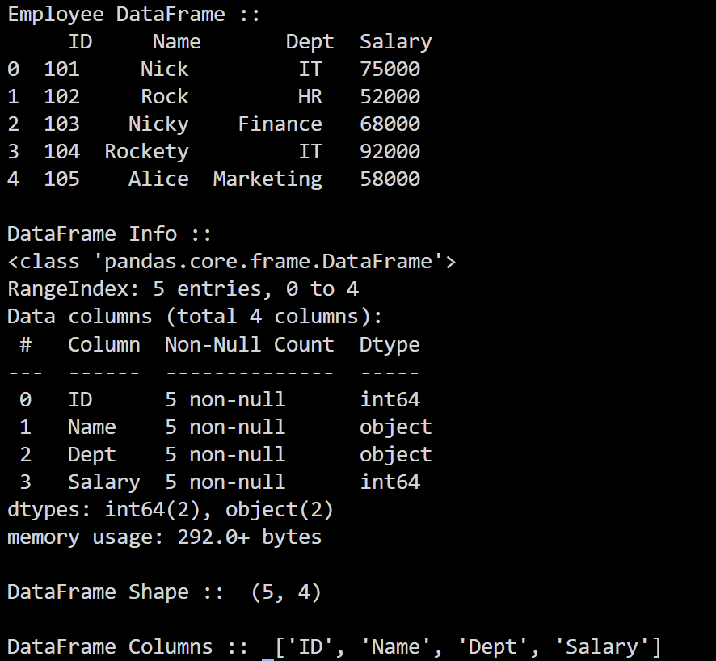
Practical :- 6.3
Aim :- Load a sample CSV file (iris.csv) into a DataFrame. Display the first 5 and last 5 rows. Use .info(), .describe(), and .shape to understand the data.
Input File (iris.csv (Sample preview)) :-
sepal_length,sepal_width,petal_length,petal_width,species
5.1,3.5,1.4,0.2,setosa
4.9,3.0,1.4,0.2,setosa
4.7,3.2,1.3,0.2,setosa
4.6,3.1,1.5,0.2,setosa
5.0,3.6,1.4,0.2,setosa
... [151 total rows in iris.csv (Sample preview)]
Program :-
import pandas as pd

df = pd.read_csv("practical 6/iris.csv")

print("First 5 Rows:\n", df.head())

print("\nLast 5 Rows:\n", df.tail())

print("\nShape:", df.shape)
print("\nInfo:")
df.info()

print("\nDescribe:")
print(df.describe().iloc[:, :4].round(2))
Output :-
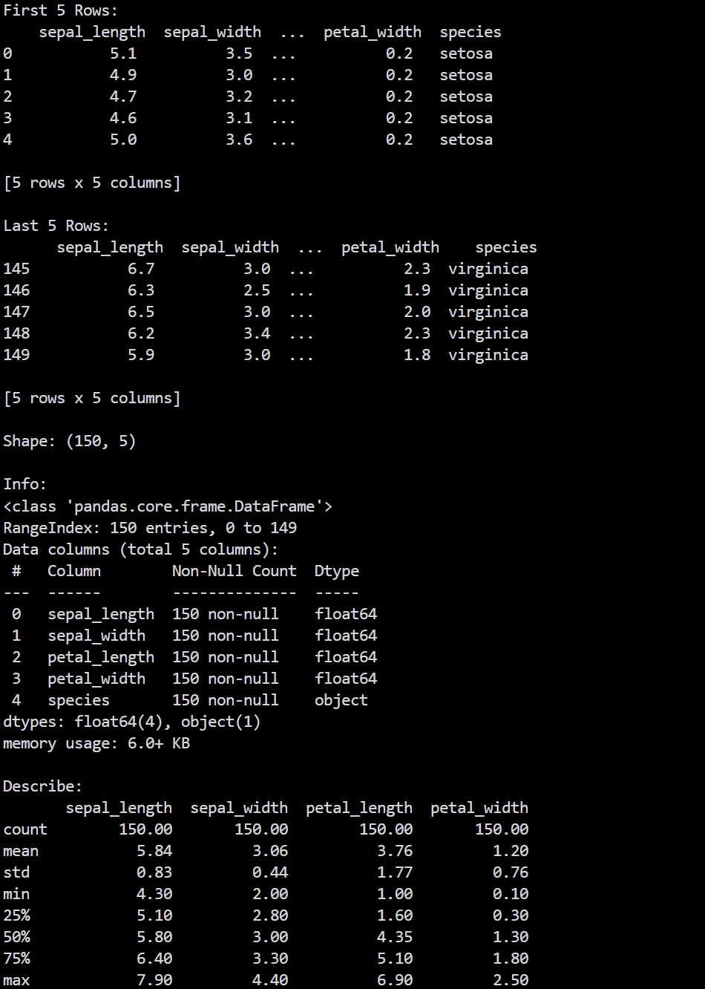
Practical :- 6.4
Aim :- Select specific columns and filter rows where the Salary/Age is greater than a certain threshold using .loc and .iloc.
Program :-
import pandas as pd

employee_data = {
"ID": [101, 102, 103, 104, 105, 106],
"Name": ["Nick", "Rock", "Nicky", "Rockety", "Alice", "Bob"],
"Age": [22, 28, 24, 32, 29, 21],
"Dept": ["IT", "HR", "Finance", "IT", "Marketing", "Finance"],
"Salary": [75000, 52000, 68000, 92000, 58000, 48000]
}

df = pd.DataFrame(employee_data)
print("Original DataFrame ::\n", df)

# Filter using .loc (label/condition based)
# Filtering employees where Salary > 60000 and selecting Name, Dept, Salary
salary_threshold = 60000
print(f"\n--- Filtering with .loc (Salary > {salary_threshold}) ---")
filtered_loc = df.loc[df["Salary"] > salary_threshold, ["Name", "Dept", "Salary"]]
print(filtered_loc)

# Filtering employees where Age > 25
age_threshold = 25
print(f"\n--- Filtering with .loc (Age > {age_threshold}) ---")
filtered_age = df.loc[df["Age"] > age_threshold, ["Name", "Age", "Dept"]]
print(filtered_age)

# Slicing and filtering using .iloc (integer-position based)
# Selecting rows 0 to 3 and columns 1 to 4 (Name, Age, Dept, Salary)
print("\n--- Selecting with .iloc (first 4 rows and columns 1 to 3) ---")
filtered_iloc = df.iloc[0:4, 1:4]
print(filtered_iloc)
Output :-
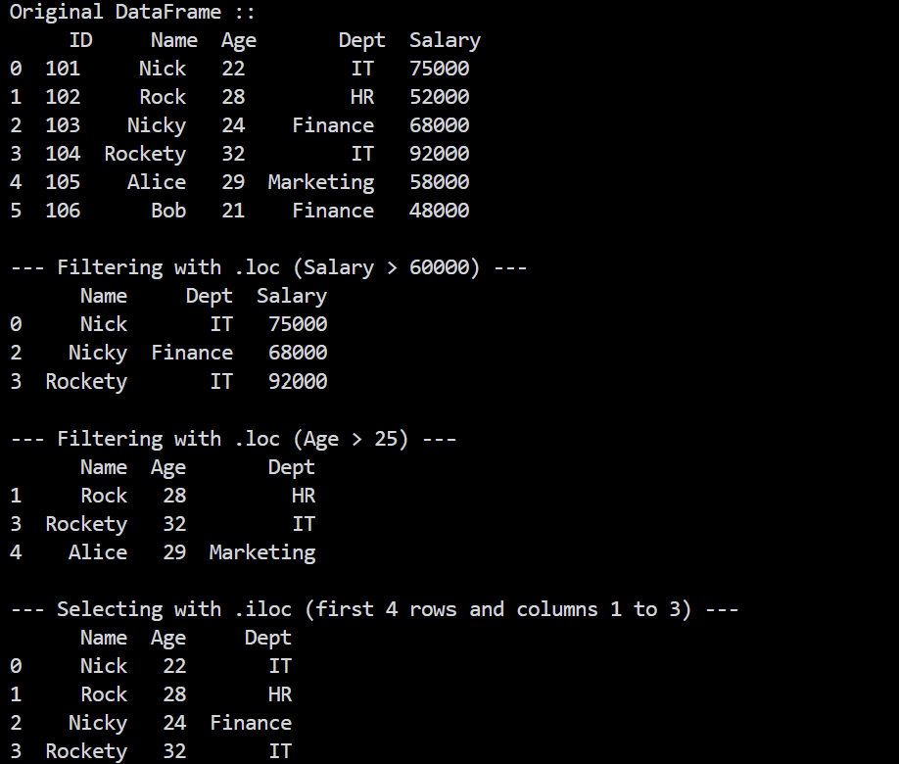

Practical :- 7.1
Aim :- Create a DataFrame with some NaN (null) values. Practice dropping rows with dropna() and filling missing values with mean/median using fillna().
Program :-
import numpy as np
import pandas as pd

# Creating DataFrame with missing (NaN) values
data = {
"Student_ID": [1, 2, 3, 4, 5, 6, 7],
"Name": ["Nick", "Rock", np.nan, "Rockety", "Alice", "Bob", "Charlie"],
"Score": [88.0, np.nan, 75.0, 92.0, np.nan, 64.0, 85.0],
"Age": [20.0, 21.0, np.nan, 22.0, 20.0, np.nan, 23.0]
}

df = pd.DataFrame(data)
print("Original DataFrame with NaN ::\n", df)

# Check null values count per column
print("\nNull values count per column ::\n", df.isnull().sum())

# 1. Dropping rows with any null value
df_dropped = df.dropna()
print("\n--- After dropna() (dropping any row with NaN) ---")
print(df_dropped)

# 2. Imputing / Filling missing values
# Filling Score column with mean, and Age column with median
df_filled = df.copy()

mean_score = df["Score"].mean()
median_age = df["Age"].median()

print(f"\nCalculated Mean Score :: {mean_score:.2f}")
print(f"Calculated Median Age :: {median_age:.1f}")

df_filled["Score"] = df_filled["Score"].fillna(mean_score)
df_filled["Age"] = df_filled["Age"].fillna(median_age)
df_filled["Name"] = df_filled["Name"].fillna("Unknown")

print("\n--- After fillna() (Score with mean, Age with median) ---")
print(df_filled)
Output :-
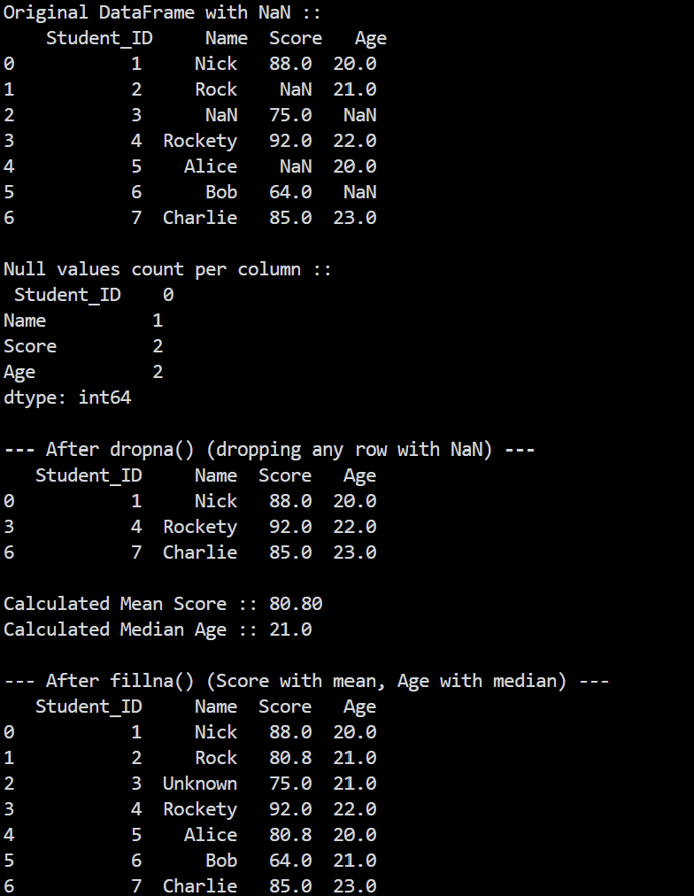
Practical :- 7.2
Aim :- Given a dataset of sales (Columns: Region, Salesperson, Profit), use groupby() to find the total profit per Region and the average profit per Salesperson.
Input File (sales_data.csv) :-
Region,Salesperson,Product,Sales,Profit
North,Nick,Electronics,12000,2500
North,Rock,Furniture,8500,1200
South,Nicky,Electronics,15000,3200
South,Rockety,Clothing,6000,900
East,Nick,Clothing,9000,1800
East,Rock,Electronics,11000,2200
West,Nicky,Furniture,14000,2900
West,Rockety,Electronics,17500,3600
... [17 total rows in sales_data.csv]
Program :-
import os
import pandas as pd

# Handle path whether executed from root or inside practical 7
csv_path = "sales_data.csv" if os.path.exists("sales_data.csv") else os.path.join("practical 7", "sales_data.csv")

df = pd.read_csv(csv_path)
print("Sales Dataset Preview ::\n", df.head(8))

# 1. Total profit per Region
total_profit_region = df.groupby("Region")["Profit"].sum()
print("\n--- Total Profit per Region ---")
print(total_profit_region)

# 2. Average profit per Salesperson
avg_profit_salesperson = df.groupby("Salesperson")["Profit"].mean()
print("\n--- Average Profit per Salesperson ---")
print(avg_profit_salesperson)

# Combined summary
print("\n--- Summary Statistics (Sum and Mean) by Region ---")
print(df.groupby("Region")["Profit"].agg(["sum", "mean", "count"]))
Output :-
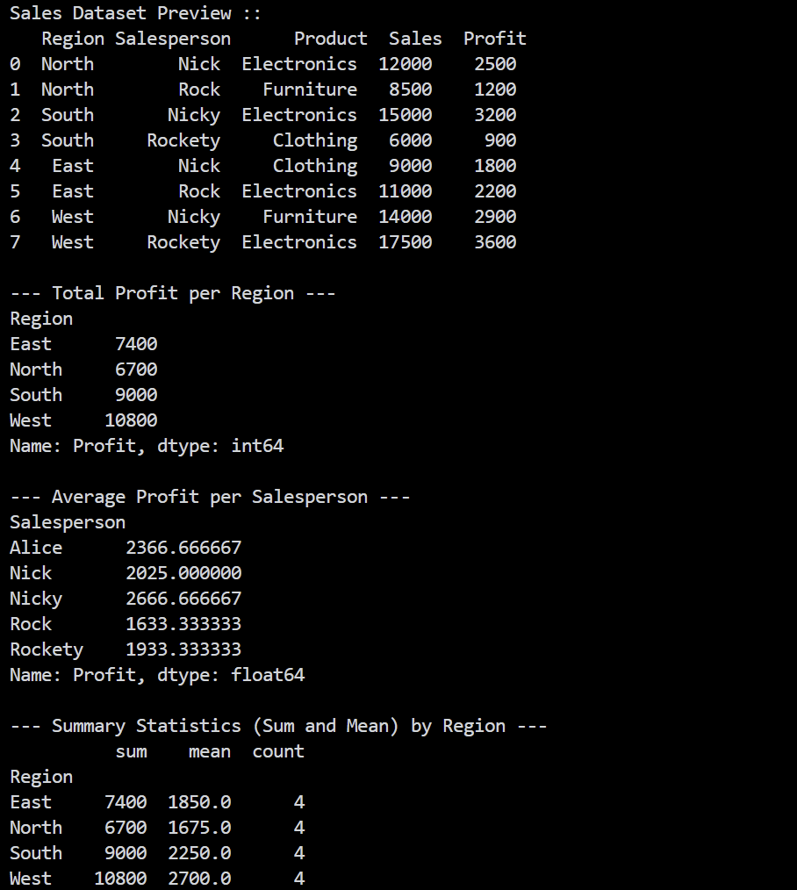
Practical :- 7.3
Aim :- Use the merge() or join() function to combine two DataFrames (an Employee details DataFrame and a Salary details DataFrame based on Employee ID).
Program :-
import pandas as pd

# DataFrame 1: Employee basic details
df_employee = pd.DataFrame({
"Employee_ID": [101, 102, 103, 104, 105],
"Name": ["Nick", "Rock", "Nicky", "Rockety", "Alice"],
"Department": ["IT", "HR", "Finance", "IT", "Marketing"]
})

# DataFrame 2: Employee salary and experience details
df_salary = pd.DataFrame({
"Employee_ID": [101, 102, 103, 104, 106],
"Salary": [75000, 52000, 68000, 92000, 48000],
"Experience_Years": [3, 2, 4, 6, 1]
})

print("Employee Details DataFrame ::\n", df_employee)
print("\nSalary Details DataFrame ::\n", df_salary)

# 1. Inner Merge (combines matching Employee_IDs)
df_inner = pd.merge(df_employee, df_salary, on="Employee_ID", how="inner")
print("\n--- Inner Merge (common Employee_IDs) ---")
print(df_inner)

# 2. Left Merge (keeps all employees from df_employee)
df_left = pd.merge(df_employee, df_salary, on="Employee_ID", how="left")
print("\n--- Left Merge (all employees from left DataFrame) ---")
print(df_left)

# 3. Outer Merge (keeps all records from both DataFrames)
df_outer = pd.merge(df_employee, df_salary, on="Employee_ID", how="outer")
print("\n--- Outer Merge (all records from both DataFrames) ---")
print(df_outer)
Output :-

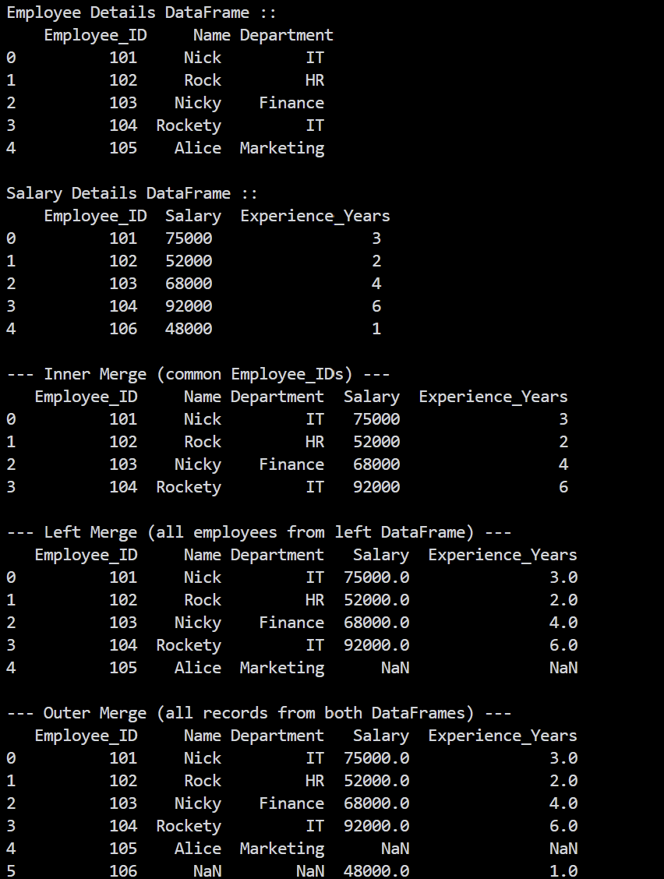
Practical :- 7.4
Aim :- Use pivot_table() to summarize data (average sales by Region and Product category).
Input File (sales_data.csv) :-
Region,Salesperson,Product,Sales,Profit
North,Nick,Electronics,12000,2500
North,Rock,Furniture,8500,1200
South,Nicky,Electronics,15000,3200
South,Rockety,Clothing,6000,900
East,Nick,Clothing,9000,1800
East,Rock,Electronics,11000,2200
West,Nicky,Furniture,14000,2900
West,Rockety,Electronics,17500,3600
... [17 total rows in sales_data.csv]
Program :-
# Use pivot_table() to summarize data (e.g., average sales by Region and
# Product category).

import os
import pandas as pd

csv_path = "sales_data.csv" if os.path.exists("sales_data.csv") else os.path.join("practical 7", "sales_data.csv")

df = pd.read_csv(csv_path)
print("Sales Data Preview ::\n", df.head())

# 1. Pivot table: Average Sales by Region and Product category
pivot_avg_sales = df.pivot_table(
values="Sales",
index="Region",
columns="Product",
aggfunc="mean"
)
print("\n--- Pivot Table: Average Sales by Region and Product ---")
print(pivot_avg_sales)

# 2. Pivot table: Total Profit with Margins (subtotals/grand totals)
pivot_total_profit = df.pivot_table(
values="Profit",
index="Region",
columns="Product",
aggfunc="sum",
fill_value=0,
margins=True,
margins_name="Total"
)
print("\n--- Pivot Table: Total Profit by Region and Product (with Margins) ---")
print(pivot_total_profit)
Output :-

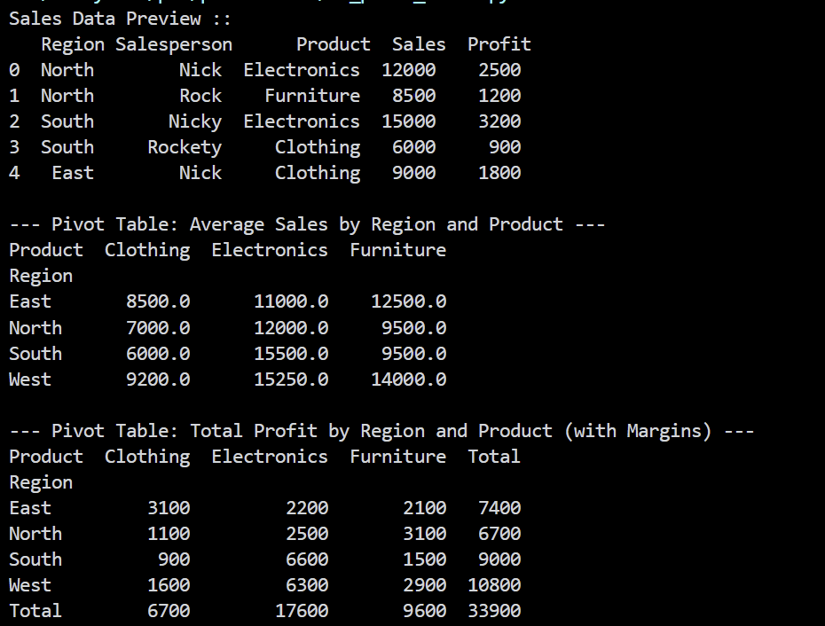

Practical :- 8.1
Aim :- Plot a Line graph showing the monthly sales of a company. Add a title, x-axis label, y-axis label, and a legend.
Program :-
# Plot a Line graph showing the monthly sales of a company. Add a title,
# x-axis label, y-axis label, and a legend.

import matplotlib.pyplot as plt

months = ["Jan", "Feb", "Mar", "Apr", "May", "Jun", "Jul", "Aug", "Sep", "Oct", "Nov", "Dec"]
sales_2023 = [12000, 15000, 14000, 18000, 22000, 24000, 21000, 26000, 28000, 31000, 35000, 42000]
sales_2024 = [14000, 17000, 16500, 21000, 25000, 28000, 27000, 30000, 33000, 37000, 41000, 48000]

plt.figure(figsize=(10, 5))
plt.plot(months, sales_2023, marker="o", color="blue", linewidth=2, label="Sales 2023")
plt.plot(months, sales_2024, marker="s", color="green", linestyle="--", linewidth=2, label="Sales 2024")

plt.title("Company Monthly Sales Trend", fontsize=14)
plt.xlabel("Month", fontsize=12)
plt.ylabel("Sales in USD ($)", fontsize=12)
plt.grid(True, linestyle=":", alpha=0.6)
plt.legend()
plt.tight_layout()

print("Displaying Line Graph...")
plt.show()
Output :-
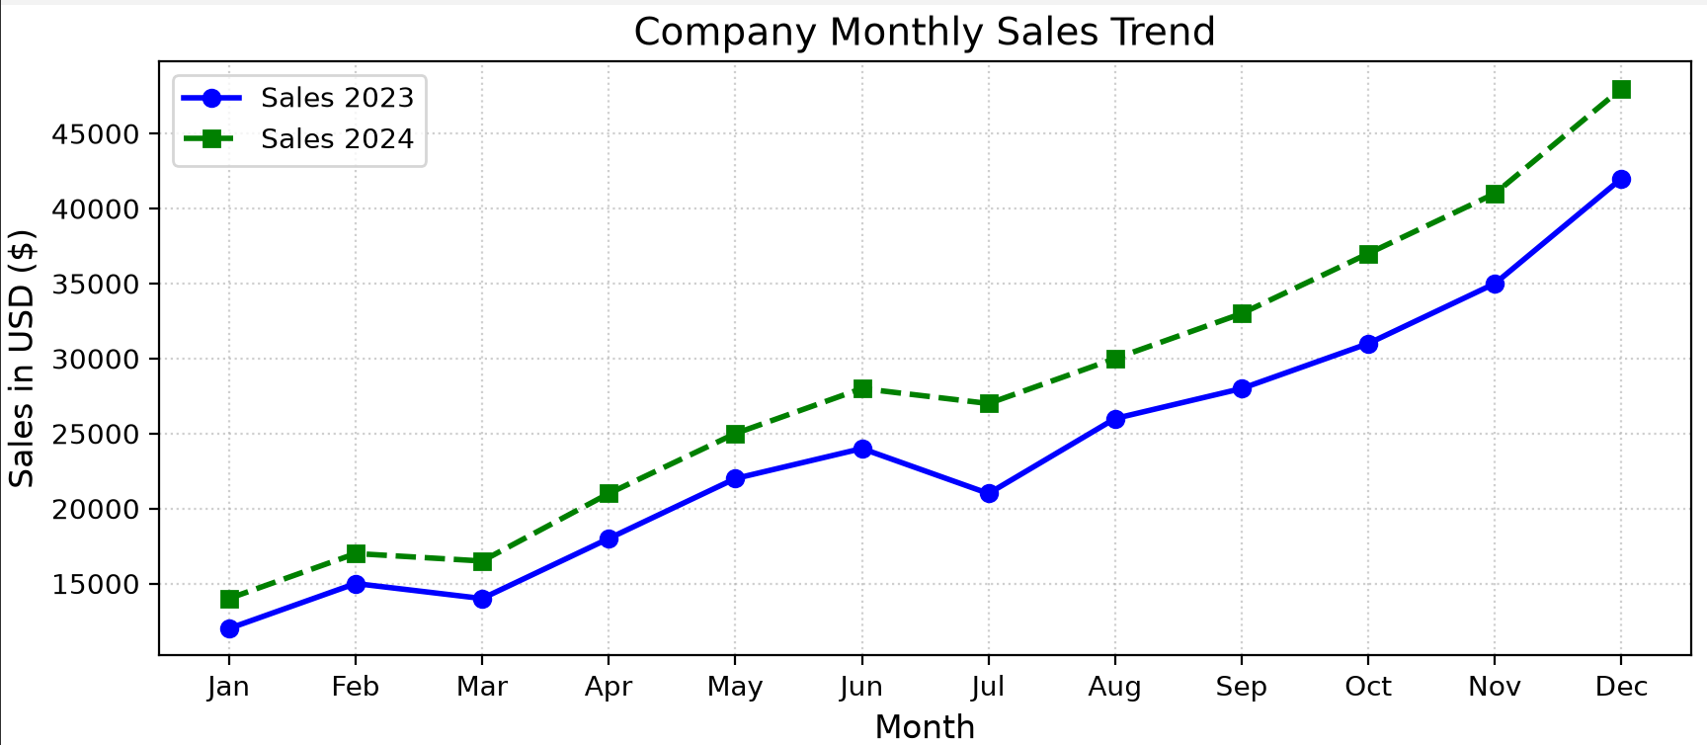
Practical :- 8.2
Aim :- Create a Bar chart comparing the marks of 5 students in Math vs. Science.
Program :-
import numpy as np
import matplotlib.pyplot as plt

students = ["Nick", "Rock", "Nicky", "Rockety", "Alice"]
math_marks = [85, 78, 92, 65, 88]
science_marks = [80, 85, 89, 72, 94]

x = np.arange(len(students))
width = 0.35

plt.figure(figsize=(8, 5))
plt.bar(x - width/2, math_marks, width, label="Math", color="royalblue", edgecolor="black")
plt.bar(x + width/2, science_marks, width, label="Science", color="coral", edgecolor="black")

plt.xlabel("Students", fontsize=12)
plt.ylabel("Marks", fontsize=12)
plt.title("Marks Comparison: Math vs Science", fontsize=14)
plt.xticks(x, students)
plt.ylim(0, 100)
plt.legend()
plt.grid(axis="y", linestyle="--", alpha=0.6)
plt.tight_layout()

print("Displaying Bar Chart...")
plt.show()
Output :-
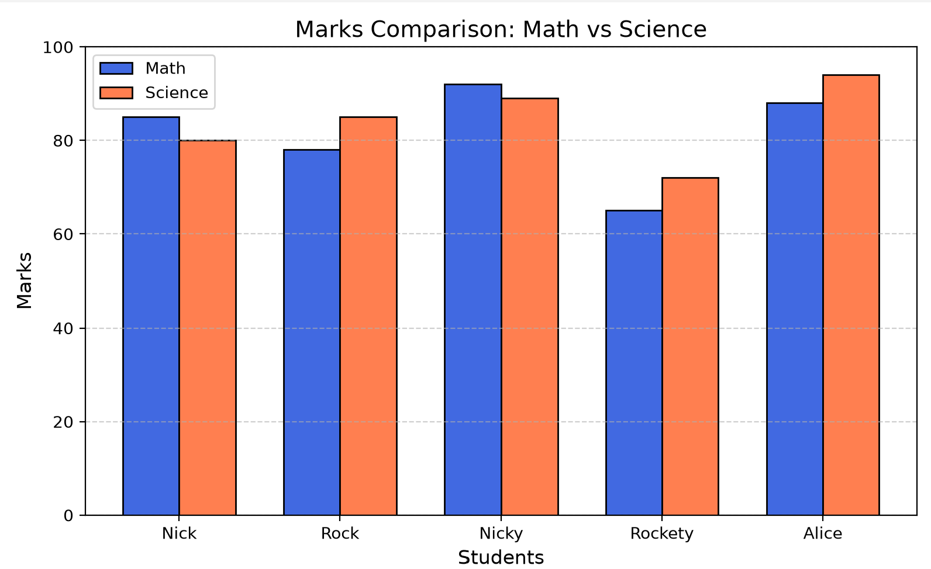
Practical :- 8.3
Aim :- Generate a Scatter plot to show the relationship between study hours and exam scores.
Program :-
import numpy as np
import matplotlib.pyplot as plt

study_hours = np.array([1.5, 2.0, 2.5, 3.0, 3.5, 4.0, 4.5, 5.0, 5.5, 6.0, 6.5, 7.0, 7.5, 8.0, 8.5])
exam_scores = np.array([45, 50, 52, 58, 63, 67, 70, 74, 78, 82, 85, 88, 91, 95, 98])

plt.figure(figsize=(8, 5))
plt.scatter(study_hours, exam_scores, color="darkviolet", s=60, edgecolors="black", label="Student Score")

# Linear trend line
m, b = np.polyfit(study_hours, exam_scores, 1)
plt.plot(study_hours, m * study_hours + b, color="crimson", linestyle="--", linewidth=1.8, label=f"Trendline (y = {m:.2f}x + {b:.2f})")

plt.title("Relationship Between Study Hours and Exam Scores", fontsize=14)
plt.xlabel("Study Hours per Day", fontsize=12)
plt.ylabel("Exam Score", fontsize=12)

plt.legend()
plt.grid(True, linestyle=":", alpha=0.6)
plt.tight_layout()

print("Displaying Scatter Plot...")
plt.show()
Output :-
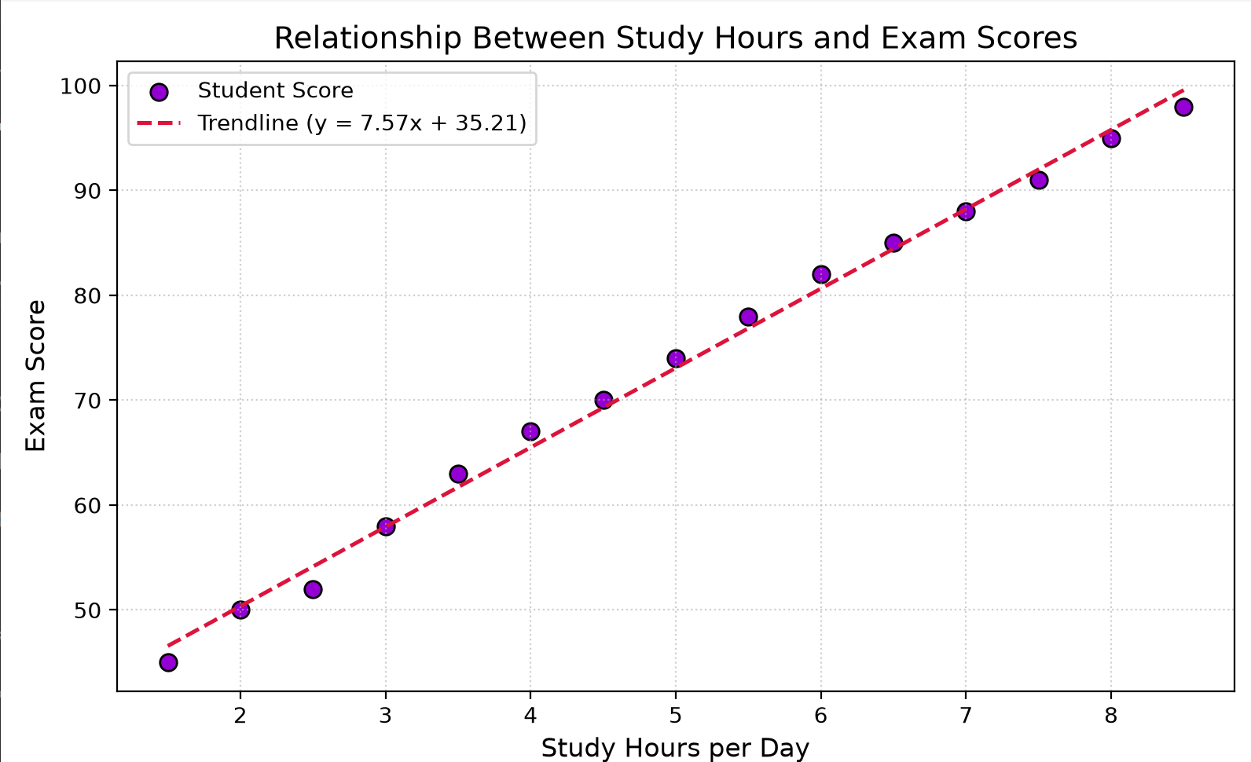
Practical :- 8.4
Aim :- Create a Histogram to show the distribution of ages in a given dataset.
Program :-
import matplotlib.pyplot as plt

ages = [18, 19, 21, 22, 22, 23, 23, 24, 25, 25, 26, 27, 28, 29, 30,
31, 32, 33, 34, 35, 36, 38, 40, 42, 45, 48, 50, 52, 55, 60]

plt.figure(figsize=(8, 5))
plt.hist(ages, bins=8, color="teal", edgecolor="black", alpha=0.75)

plt.title("Age Distribution of Participants", fontsize=14)
plt.xlabel("Age", fontsize=12)
plt.ylabel("Frequency", fontsize=12)
plt.grid(axis="y", linestyle="--", alpha=0.6)
plt.tight_layout()

print("Displaying Histogram...")
plt.show()
Output :-
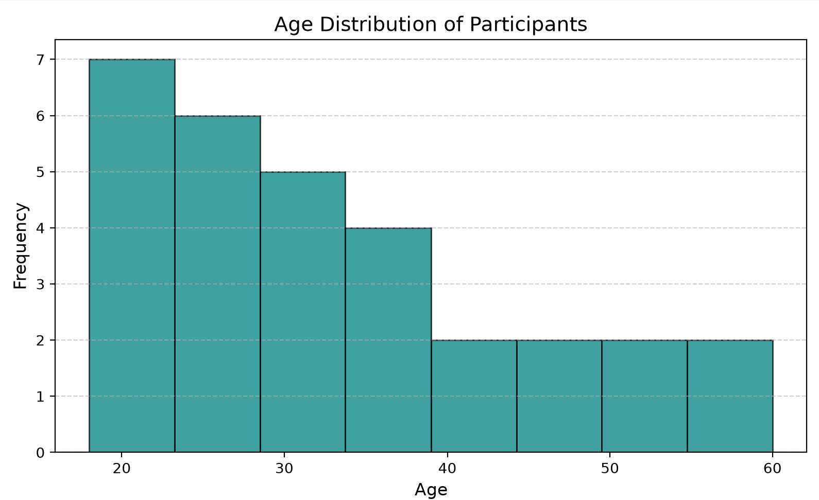

Practical :- 9.1
Aim :- Load the built-in tips or iris dataset from Seaborn.
Program :-
import seaborn as sns

# Load built-in 'tips' dataset
tips = sns.load_dataset("tips")

print("--- Tips Dataset First 5 Rows (.head()) ---")
print(tips.head())

print("\n--- Tips Dataset Information (.info()) ---")
tips.info()

print("\n--- Tips Dataset Summary Statistics (.describe()) ---")
print(tips.describe())

# Load built-in 'iris' dataset
iris = sns.load_dataset("iris")
print("\n--- Iris Dataset First 5 Rows (.head()) ---")
print(iris.head())
print("\nIris Dataset Shape :: ", iris.shape)
Output :-
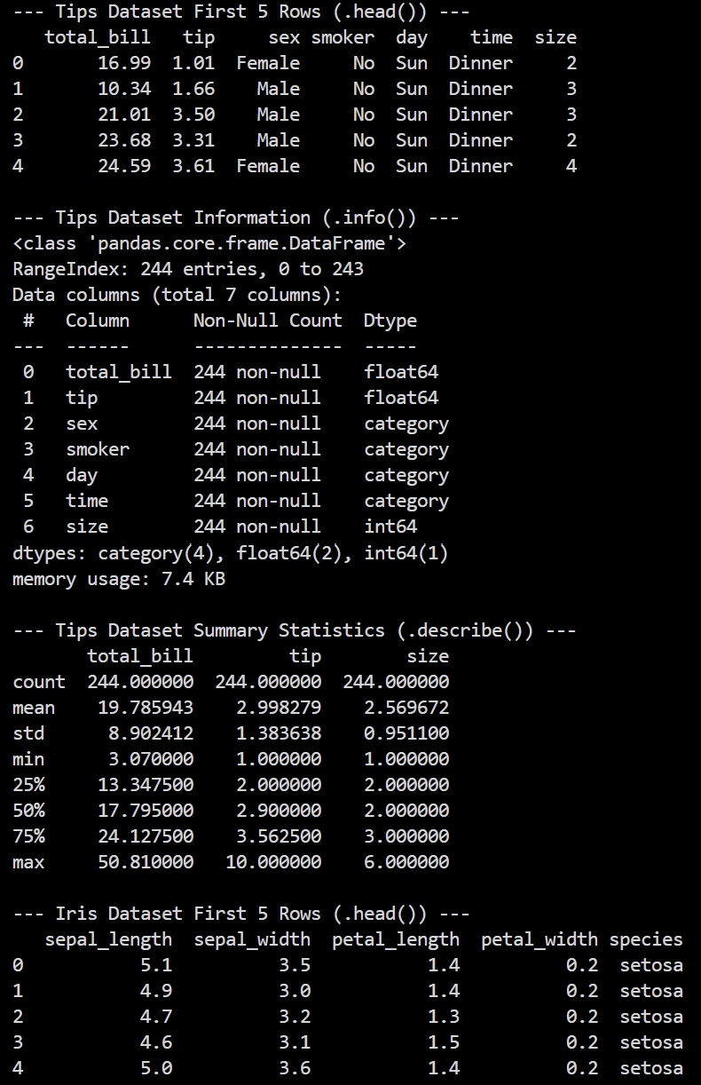
Practical :- 9.2
Aim :- Create a Boxplot to visualize the distribution of total bills across different days of the week.
Program :-
import matplotlib.pyplot as plt
import seaborn as sns

# Load dataset
tips = sns.load_dataset("tips")

# Set theme
sns.set_theme(style="whitegrid")

plt.figure(figsize=(9, 5))
sns.boxplot(
x="day",
y="total_bill",
hue="sex",
data=tips,
palette="Set2"
)

plt.title("Distribution of Total Bills Across Days of the Week", fontsize=14)
plt.xlabel("Day of the Week", fontsize=12)
plt.ylabel("Total Bill ($)", fontsize=12)
plt.legend(title="Gender", loc="upper left")
plt.tight_layout()

print("Displaying Boxplot...")
plt.show()
Output :-
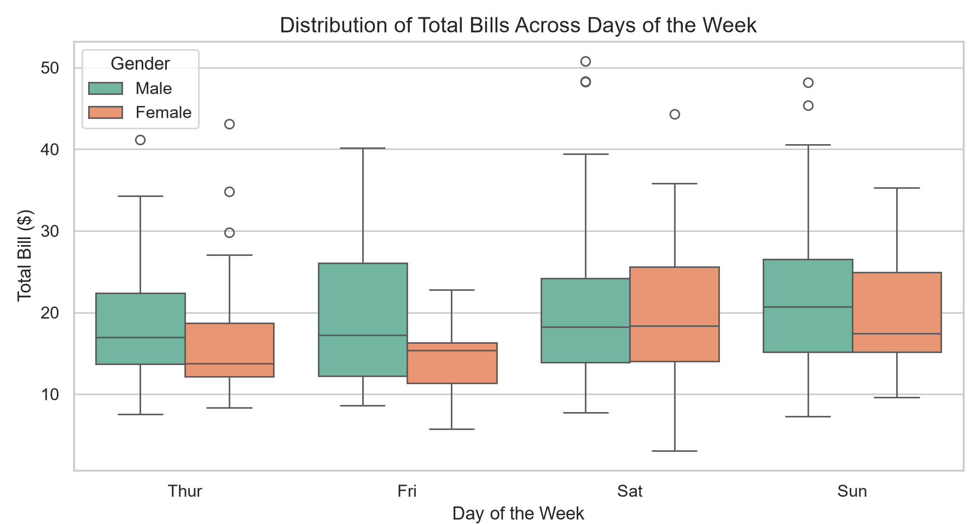
Practical :- 9.3
Aim :- Plot a Heatmap of the correlation matrix of the iris dataset. Annotate the heatmap with correlation values.
Program :-
import matplotlib.pyplot as plt
import seaborn as sns

# Load dataset
iris = sns.load_dataset("iris")

# Calculate correlation matrix for numeric columns
correlation_matrix = iris.corr(numeric_only=True)
print("Iris Correlation Matrix ::\n", correlation_matrix)

plt.figure(figsize=(8, 6))
sns.heatmap(
correlation_matrix,
annot=True,
fmt=".2f",
cmap="coolwarm",
linewidths=0.5,
cbar_kws={"label": "Correlation Coefficient"}
)

plt.title("Correlation Heatmap of Iris Dataset Features", fontsize=14)
plt.tight_layout()

print("Displaying Heatmap...")
plt.show()
Output :-
Iris Correlation Matrix ::
sepal_length sepal_width petal_length petal_width
sepal_length 1.000000 -0.117570 0.871754 0.817941
sepal_width -0.117570 1.000000 -0.428440 -0.366126
petal_length 0.871754 -0.428440 1.000000 0.962865
petal_width 0.817941 -0.366126 0.962865 1.000000
Displaying Heatmap...
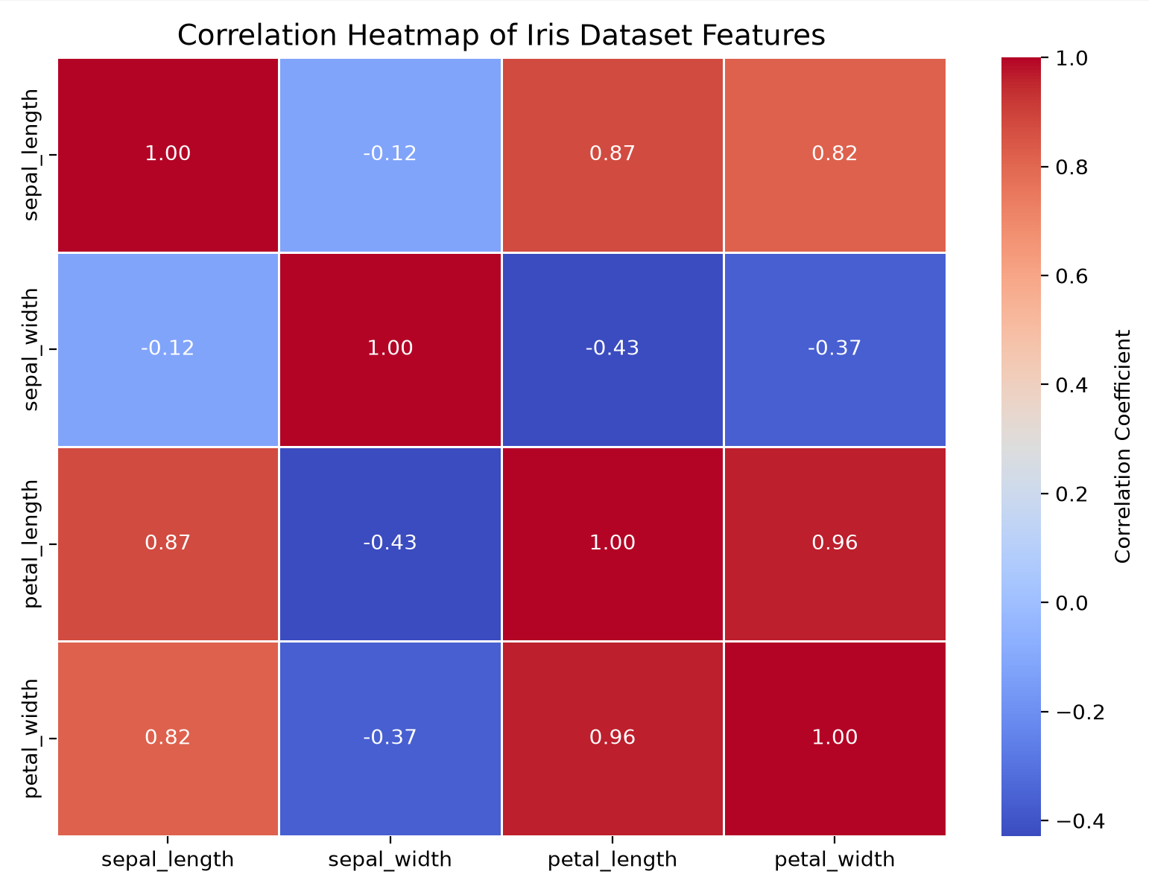
Practical :- 9.4
Aim :- Create a Pairplot to visualize pairwise relationships in the dataset, colored by the species/target column.
Program :-
import matplotlib.pyplot as plt
import seaborn as sns

# Load iris dataset
iris = sns.load_dataset("iris")

print("Iris Species Distribution ::\n", iris["species"].value_counts())

# Generate Pairplot

pair_plot = sns.pairplot(
iris,
hue="species",
palette="Dark2",
markers=["o", "s", "D"],
diag_kind="kde"
)

pair_plot.fig.suptitle("Pairwise Relationships in Iris Dataset by Species", y=1.02, fontsize=14)

print("Displaying Pairplot...")
plt.show()
Output :-
Iris Species Distribution ::
species
setosa 50
versicolor 50
virginica 50
Name: count, dtype: int64
Displaying Pairplot...
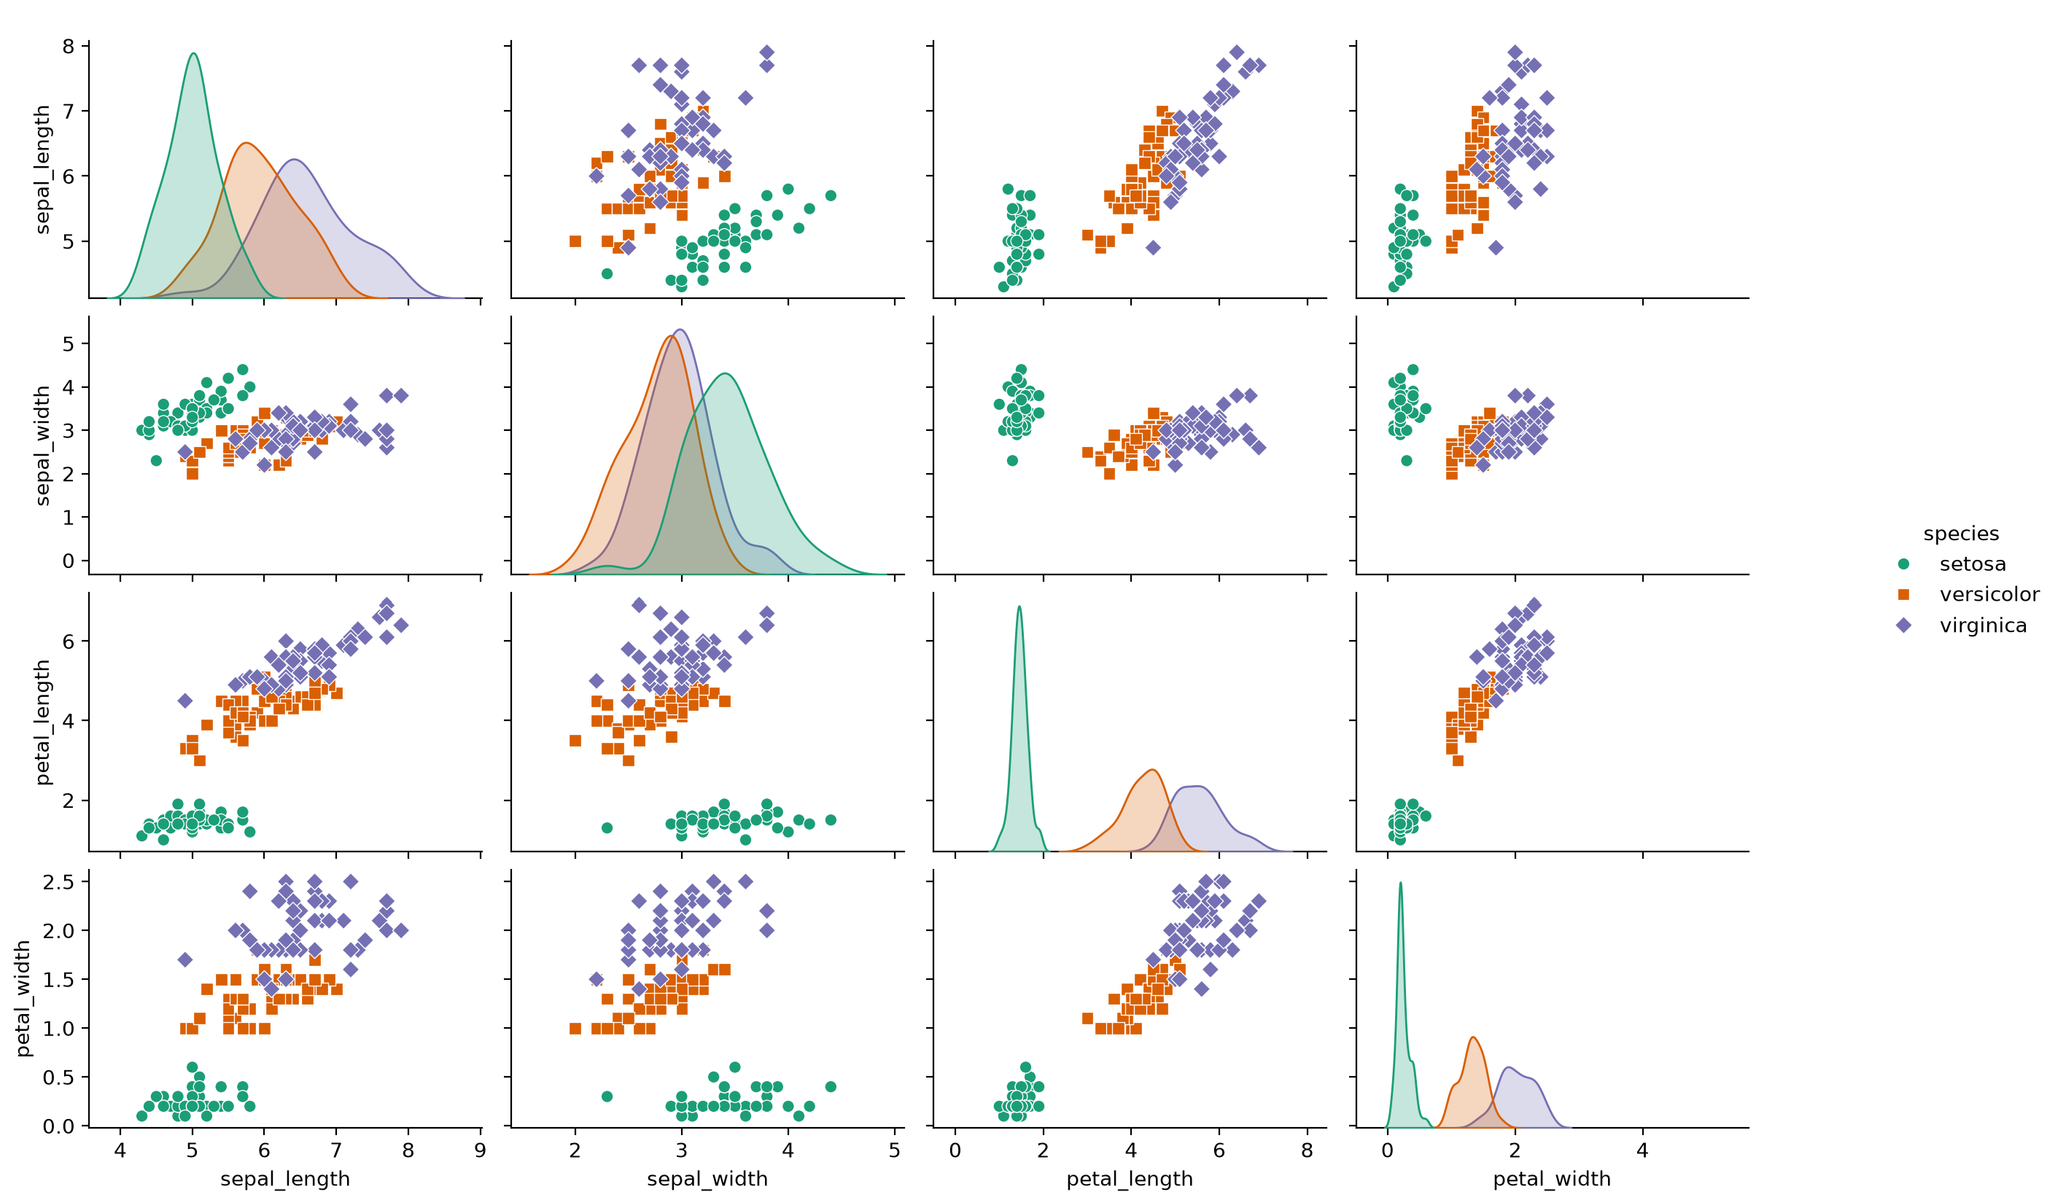

Practical :- 10
Aim :- To apply data loading, cleaning, and statistical analysis to a real-world dataset (Titanic Dataset from Kaggle).
Input File (titanic.csv (Sample preview)) :-
PassengerId,Survived,Pclass,Name,Sex,Age,SibSp,Parch,Ticket,Fare,Cabin,Embarked
1,0,3,"Braund, Mr. Owen Harris",male,22,1,0,A/5 21171,7.25,,S
2,1,1,"Cumings, Mrs. John Bradley (Florence Briggs Thayer)",female,38,1,0,PC 17599,71.2833,C85,C
3,1,3,"Heikkinen, Miss. Laina",female,26,0,0,STON/O2. 3101282,7.925,,S
4,1,1,"Futrelle, Mrs. Jacques Heath (Lily May Peel)",female,35,1,0,113803,53.1,C123,S
5,0,3,"Allen, Mr. William Henry",male,35,0,0,373450,8.05,,S
... [892 total rows in titanic.csv (Sample preview)]
Program :-
import os
import urllib.request
import pandas as pd

# Task 1: Dataset loading (download if not present)
csv_path = "titanic.csv" if os.path.exists("titanic.csv") else os.path.join("practical 10", "titanic.csv")
if not os.path.exists(csv_path):
url = "https://raw.githubusercontent.com/datasciencedojo/datasets/master/titanic.csv"
print("Downloading Titanic dataset from URL :: ", url)
urllib.request.urlretrieve(url, csv_path)

df = pd.read_csv(csv_path)
print("--- Titanic Dataset Preview ---")
print(df.head())
print("\nInitial Dataset Shape :: ", df.shape)

# Task 2: Identify and handle missing values
print("\n--- Missing Values Count per Column ---")
print(df.isnull().sum())

# Handle missing Age by filling with median
median_age = df["Age"].median()
df["Age"] = df["Age"].fillna(median_age)
print(f"\nMissing Age filled with median :: {median_age:.1f}")

# Handle missing Embarked by filling with mode
mode_embarked = df["Embarked"].mode()[0]
df["Embarked"] = df["Embarked"].fillna(mode_embarked)
print(f"Missing Embarked filled with mode :: {mode_embarked}")

# Drop Cabin due to excessive missing values
if "Cabin" in df.columns:
df.drop(columns=["Cabin"], inplace=True)
print("Dropped Cabin column due to high proportion of missing values.")

print("\nMissing values after cleaning ::\n", df.isnull().sum())

# Task 3: Extract statistical insights for numerical columns
numerical_cols = ["Age", "Fare", "SibSp", "Parch"]

print("\n--- Statistical Insights for Numerical Columns ---")
for col in numerical_cols:
mean_val = df[col].mean()
median_val = df[col].median()
std_val = df[col].std()
print(f"\nColumn :: {col}")
print(f"Mean :: {mean_val:.2f}")
print(f"Median :: {median_val:.2f}")
print(f"Standard Deviation :: {std_val:.2f}")

# Task 4: Identify and remove duplicate rows, and convert categorical text into numerical
duplicate_count = df.duplicated().sum()
print("\n--- Duplicate Rows Check ---")
print("Number of duplicate rows found :: ", duplicate_count)
if duplicate_count > 0:
df.drop_duplicates(inplace=True)
print("Duplicates removed successfully.")

print("\n--- Categorical Conversion ---")
# Convert 'Sex' to numerical (male: 0, female: 1)
df["Sex"] = df["Sex"].map({"male": 0, "female": 1})
print("Mapped 'Sex' column :: male -> 0, female -> 1")

# Map 'Embarked' to numerical (C: 0, Q: 1, S: 2)
df["Embarked"] = df["Embarked"].map({"C": 0, "Q": 1, "S": 2})
print("Mapped 'Embarked' column :: C -> 0, Q -> 1, S -> 2")

print("\n--- Final Cleaned DataFrame Preview ---")
print(df[["PassengerId", "Survived", "Pclass", "Sex", "Age", "SibSp", "Parch", "Fare", "Embarked"]].head())
print("\nFinal Cleaned DataFrame Info ::")
df.info()
Output :-
--- Titanic Dataset Preview ---
PassengerId Survived Pclass ... Fare Cabin Embarked
0 1 0 3 ... 7.2500 NaN S
1 2 1 1 ... 71.2833 C85 C
2 3 1 3 ... 7.9250 NaN S
3 4 1 1 ... 53.1000 C123 S
4 5 0 3 ... 8.0500 NaN S

[5 rows x 12 columns]

Initial Dataset Shape :: (891, 12)

--- Missing Values Count per Column ---
PassengerId 0
Survived 0
Pclass 0
Name 0
Sex 0
Age 177
SibSp 0
Parch 0
Ticket 0
Fare 0
Cabin 687
Embarked 2
dtype: int64

Missing Age filled with median :: 28.0
Missing Embarked filled with mode :: S
Dropped Cabin column due to high proportion of missing values.

Missing values after cleaning ::
PassengerId 0
Survived 0
Pclass 0
Name 0
Sex 0
Age 0
SibSp 0
Parch 0
Ticket 0
Fare 0
Embarked 0
dtype: int64

--- Statistical Insights for Numerical Columns ---

Column :: Age
Mean :: 29.36
Median :: 28.00
Standard Deviation :: 13.02

Column :: Fare
Mean :: 32.20
Median :: 14.45
Standard Deviation :: 49.69

Column :: SibSp
Mean :: 0.52
Median :: 0.00
Standard Deviation :: 1.10

Column :: Parch
Mean :: 0.38
Median :: 0.00
Standard Deviation :: 0.81

--- Duplicate Rows Check ---
Number of duplicate rows found :: 0

--- Categorical Conversion ---
Mapped 'Sex' column :: male -> 0, female -> 1
Mapped 'Embarked' column :: C -> 0, Q -> 1, S -> 2

--- Final Cleaned DataFrame Preview ---
PassengerId Survived Pclass Sex Age SibSp Parch Fare Embarked
0 1 0 3 0 22.0 1 0 7.2500 2
1 2 1 1 1 38.0 1 0 71.2833 0
2 3 1 3 1 26.0 0 0 7.9250 2
3 4 1 1 1 35.0 1 0 53.1000 2
4 5 0 3 0 35.0 0 0 8.0500 2

Final Cleaned DataFrame Info ::
<class 'pandas.core.frame.DataFrame'>
RangeIndex: 891 entries, 0 to 890
Data columns (total 11 columns):
# Column Non-Null Count Dtype
--- ------ -------------- -----
0 PassengerId 891 non-null int64
1 Survived 891 non-null int64
2 Pclass 891 non-null int64
3 Name 891 non-null object
4 Sex 891 non-null int64

5 Age 891 non-null float64
6 SibSp 891 non-null int64
7 Parch 891 non-null int64
8 Ticket 891 non-null object
9 Fare 891 non-null float64
10 Embarked 891 non-null int64
dtypes: float64(2), int64(7), object(2)
memory usage: 76.7+ KB

Practical :- Beyond Syllabus 1
Aim :- To perform advanced data manipulation and visual storytelling using groupby survival metrics and 4 distinct visualizations.
Input File (titanic.csv (Sample preview)) :-
PassengerId,Survived,Pclass,Name,Sex,Age,SibSp,Parch,Ticket,Fare,Cabin,Embarked
1,0,3,"Braund, Mr. Owen Harris",male,22,1,0,A/5 21171,7.25,,S
2,1,1,"Cumings, Mrs. John Bradley (Florence Briggs Thayer)",female,38,1,0,PC 17599,71.2833,C85,C
3,1,3,"Heikkinen, Miss. Laina",female,26,0,0,STON/O2. 3101282,7.925,,S
4,1,1,"Futrelle, Mrs. Jacques Heath (Lily May Peel)",female,35,1,0,113803,53.1,C123,S
5,0,3,"Allen, Mr. William Henry",male,35,0,0,373450,8.05,,S
... [892 total rows in titanic.csv (Sample preview)]
Program :-
import pandas as pd
import matplotlib.pyplot as plt
import seaborn as sns

df = pd.read_csv("titanic.csv")

# 1. Survival rates
print("Survival Rate by Gender:")
print(df.groupby("Sex")["Survived"].mean())

print("\nSurvival Rate by Class:")
print(df.groupby("Pclass")["Survived"].mean())

# 2. Visualizations

# Graph 1: Survival by Gender
sns.barplot(x="Sex", y="Survived", data=df)
plt.title("Survival Rate by Gender")
plt.show()

# Graph 2: Survival by Class
sns.barplot(x="Pclass", y="Survived", data=df)
plt.title("Survival Rate by Passenger Class")
plt.show()

# Graph 3: Age Distribution
sns.histplot(df["Age"].dropna(), bins=20)
plt.title("Age Distribution")
plt.show()

# Graph 4: Correlation Heatmap
corr = df[["Survived", "Pclass", "Age", "Fare"]].corr()
sns.heatmap(corr, annot=True)
plt.title("Correlation Heatmap")

plt.show()

# 3. Summary
print("\nInsights:")
print("1. Females had a higher survival rate than males.")
print("2. First-class passengers had better survival rates.")
print("3. Most passengers were young to middle-aged adults.")
print("4. Passenger class and fare show a relationship with survival.")
Output :-
Survival Rate by Gender:
Sex
female 0.742038
male 0.188908
Name: Survived, dtype: float64

Survival Rate by Class:
Pclass
1 0.629630
2 0.472826
3 0.242363
Name: Survived, dtype: float64

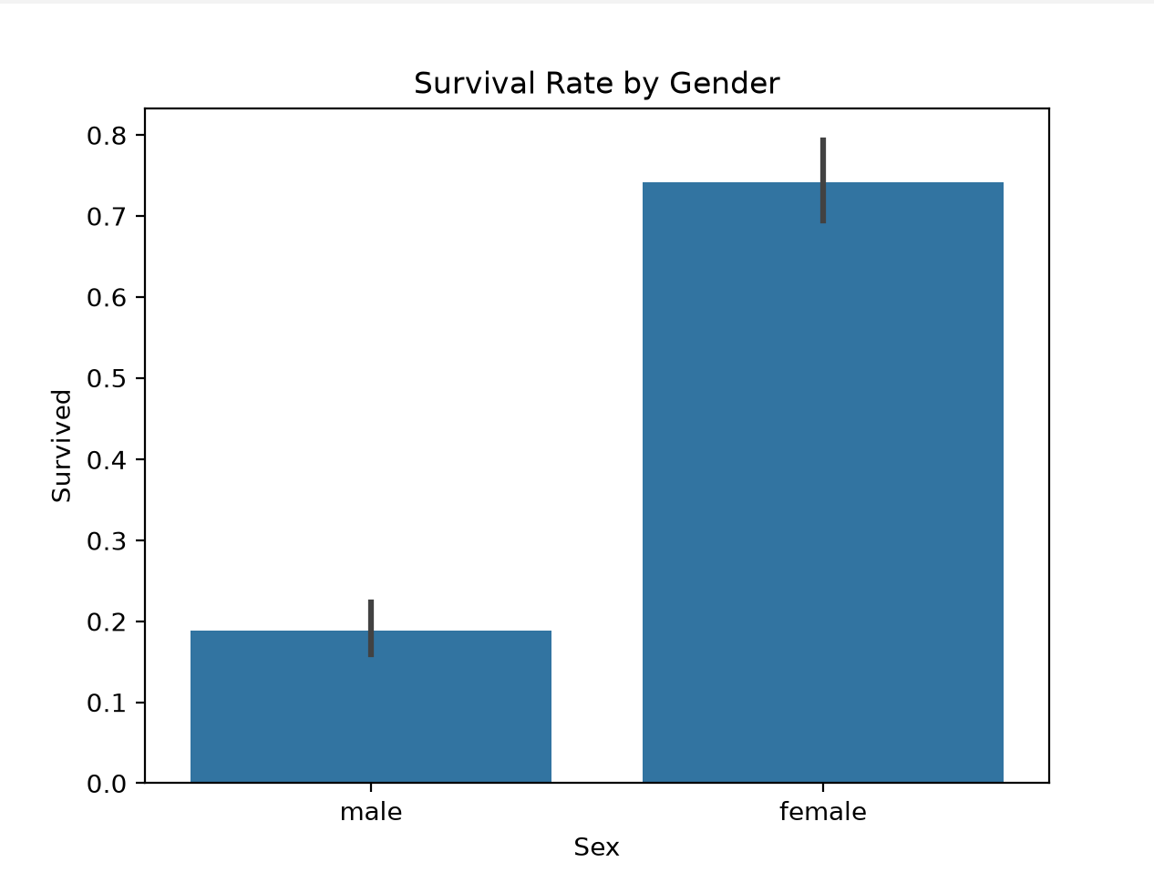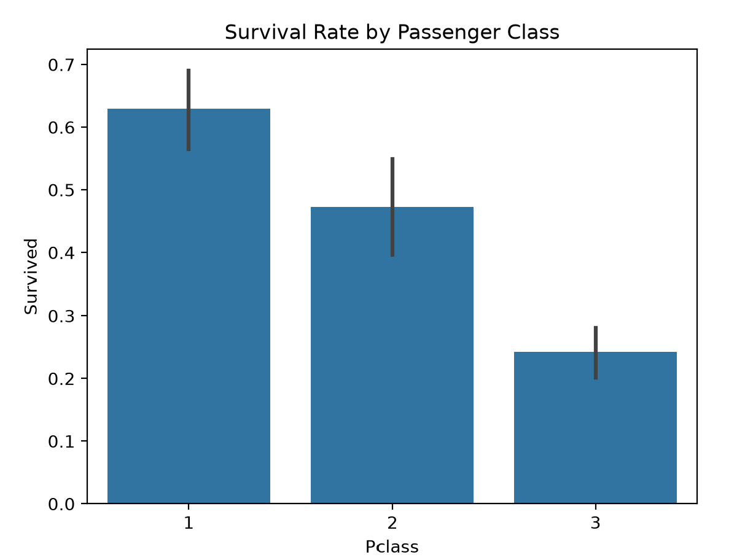
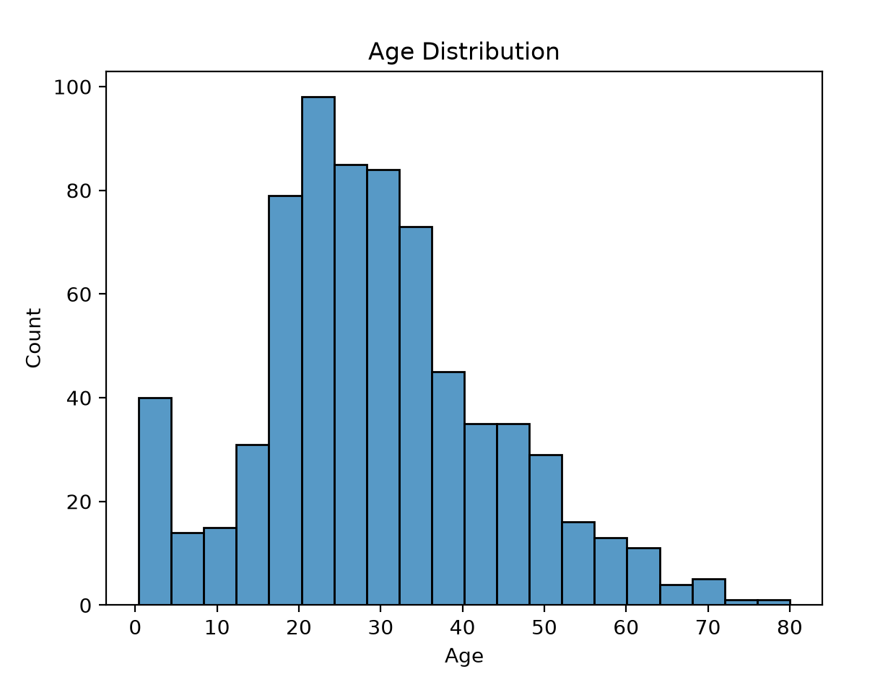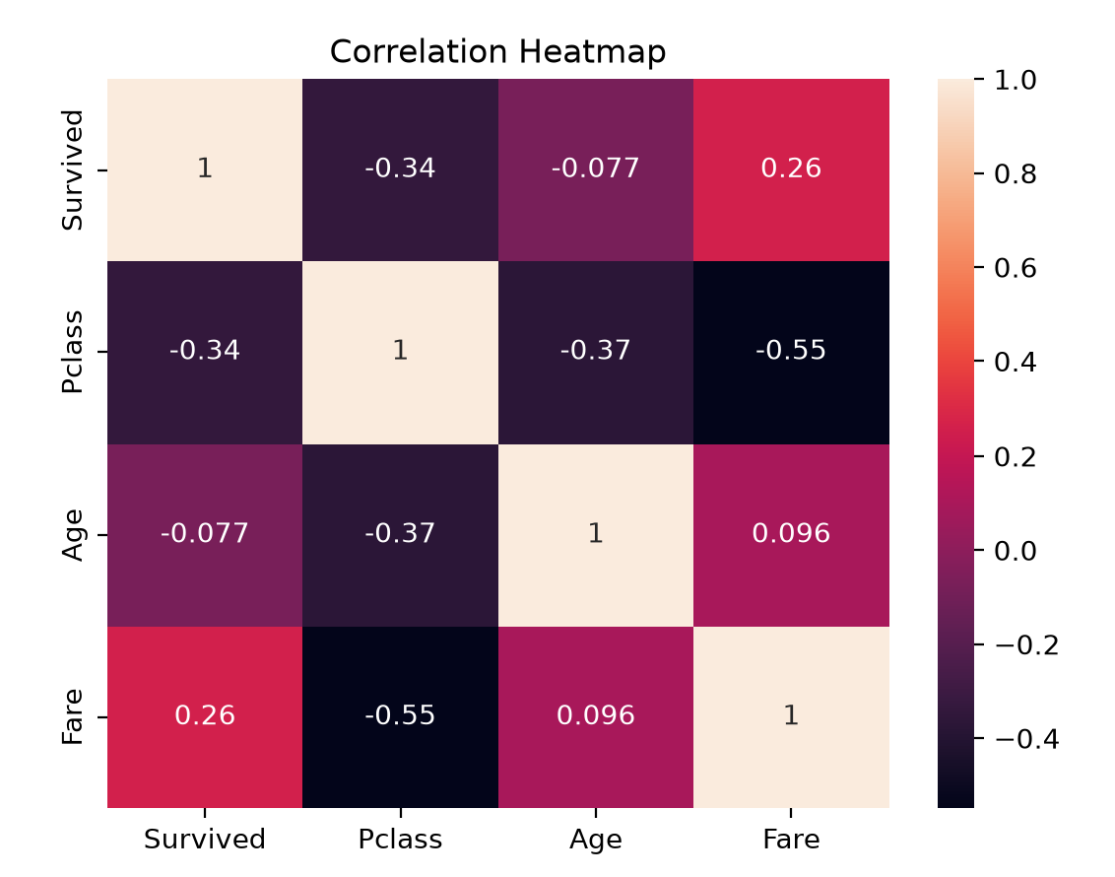

Practical :- Beyond Syllabus 2
Aim :- To test the overall understanding of the Python for Data Science pipeline: read messy CSV, clean nulls/types/duplicates/outliers, compute statistics, answer analytical question, and generate final visualization.
Input File (messy_sales_data.csv (Sample preview)) :-
Transaction_ID,Date,Region,Branch,Category,Sales,Profit,Discount,Customer_Rating
T001,2024-01-05,North,Downtown,Electronics,"$1,200.00",300.0,0.1,4.5
T002,2024-01-06,North,Downtown,Clothing,"$450.00",120.0,0.05,4.0
T003,2024-01-07,South,Suburbs,Furniture,"$850.00",-50.0,0.2,3.5
T004,2024-01-08,East,Uptown,Electronics,"$2,300.00",580.0,0.15,4.8
T005,2024-01-09,West,Downtown,Clothing,"$310.00",90.0,,4.2
T006,2024-01-10,North,Uptown,Furniture,,220.0,0.1,3.8
T007,2024-01-11,South,Downtown,Electronics,"$1,750.00",410.0,0.05,4.6
T008,2024-01-12,East,Suburbs,Clothing,"$620.00",180.0,0.1,
T009,2024-01-13,West,Uptown,Electronics,"$99,999.00",45000.0,0.5,2.0
... [22 total rows in messy_sales_data.csv (Sample preview)]
Program :-
import pandas as pd
import matplotlib.pyplot as plt
import seaborn as sns

# 1. Read CSV
df = pd.read_csv("messy_sales_data.csv")

# 2. Clean data
df.drop_duplicates(inplace=True)

df["Sales"] = df["Sales"].replace(r"[$,]", "", regex=True).astype(float)

df["Sales"] = df["Sales"].fillna(df["Sales"].median())
df["Discount"] = df["Discount"].fillna(df["Discount"].median())
df["Customer_Rating"] = df["Customer_Rating"].fillna(df["Customer_Rating"].mean())

# Remove Sales outliers using IQR
Q1 = df["Sales"].quantile(0.25)
Q3 = df["Sales"].quantile(0.75)
IQR = Q3 - Q1

df = df[(df["Sales"] >= Q1 - 1.5 * IQR) &
(df["Sales"] <= Q3 + 1.5 * IQR)]

# 3. Basic statistics
print("Statistics:")
print(df[["Sales", "Profit", "Discount", "Customer_Rating"]].describe().round(2))

# 4. Find highest profit margin
df["Profit_Margin"] = (df["Profit"] / df["Sales"]) * 100

result = df.groupby(["Branch", "Category"])["Profit_Margin"].mean().reset_index()

top = result.loc[result["Profit_Margin"].idxmax()]

print("\nHighest Profit Margin:")
print(top)

# 5. Final visualization

pivot = result.pivot(index="Branch",
columns="Category",
values="Profit_Margin")

sns.heatmap(pivot, annot=True, fmt=".1f")
plt.title("Profit Margin by Branch and Category")
plt.xlabel("Category")
plt.ylabel("Branch")
plt.show()

Output :-
